Princess Sumaya University for Technology

King Abdullah II Faculty of Engineering

Electrical Engineering Department



**Microprocessors and Embedded Systems Project**

**4x4x4 LED Cube**

***Authors: Supervisor:***

Tareq Hasan 20190665 Dr. Belal Sababha

Yazan Jizawi 20200317

Mohammad Tarifi 20201191

*June 5, 2023*

# Abstract

The aim of this project is to develop an embedded system using PIC16F877A and other components that serve the purpose of the system. Dealing with interrupts is a crucial part of this project due to its nature and how it is designed.

# Introduction

Our main goal of this project is creating a 4x4x4 LED cube and presenting our knowledge in developing an embedded system that functions effectively and efficiently. The cube consists mainly of 2 modes. The first mode is the standby mode where the cube calls the functions to light up the LEDs in a certain manner. The second mode is the microphone mode, where it is triggered by pressing a push button interfaced at pin RB0. When the button is pressed again the cube goes back to standby mode.

# Design

The hardware design is a challenging part in almost every industry. In this project we used copper wires of 1.1 mm thickness and dimensions of 4cm x 4cm x 4cm for the cube. The copper wires were straightened by hand and then soldered to a shape of a cube and the LEDs were connected to a common anode to each row of the cube and the cathodes to the vertical copper wires and all vertical copper wires are connected to different pins on the microcontroller.

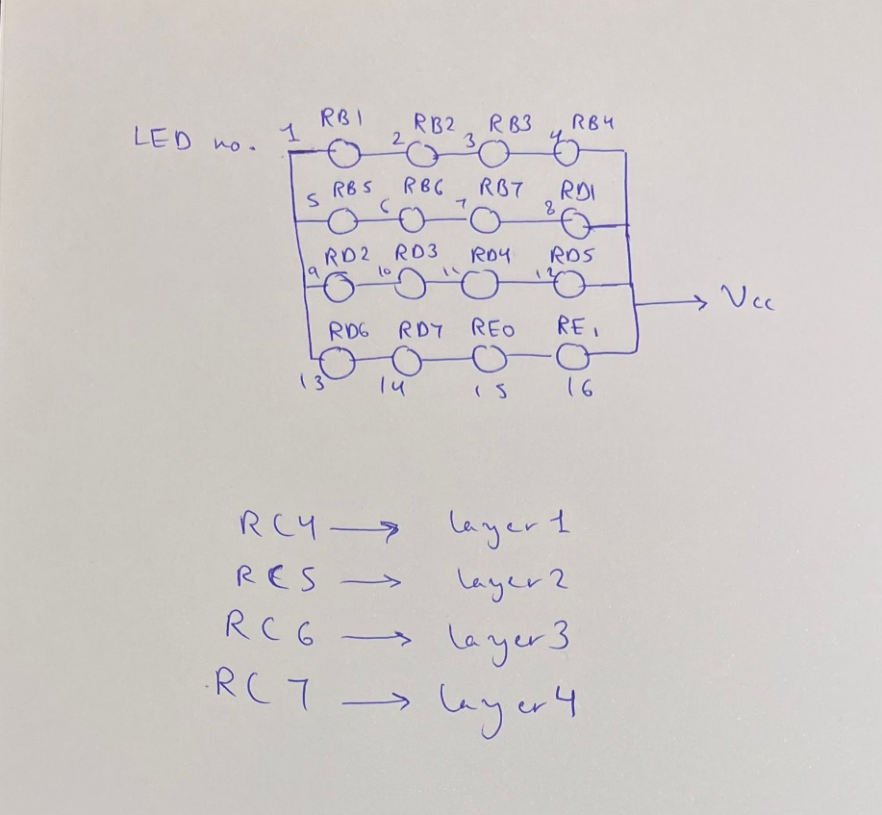

Figure 1: top view of each layer

The circuit designed consisted mainly of our microcontroller PIC16F877A, 64 LEDs, 4 PNP Transistor of type 2N3906, sound detector and a push button. The 2N3906 functions as a voltage gate to connect every level of the cube to the power source without burning the LEDs. The PNP transistor turns on by low (0) signal. The emitters of all of the transistor are connected to the power source, the base of each transistor is connected to a different pin to decide when to switch on or off a certain LED and the collector is connected directly to the anodes to sink current to the LEDs. The sound detector is connected to pin RA0 which consists of an analog to digital convertor that allows us to convert the sound waves detected by the sound detector to digital inputs for the microcontroller to comprehend them.

The software design was the most challenging part in this project. A code of 1043 lines was constructed from scratch by implementing C and some Assembly. The code instructs the cube to call functions that were created to animate and move the cube around. In addition, it consists of an interrupt service routine that is associated with an unsigned character called flip, where the character is complemented each time the push button interfaced on pin RB0 is pressed. The interrupt is used to move the program counter from carrying out standby mode functions to microphone mode.

Figure 1 illustrates which pin each cathode of every layer was connected to (vertical bars are the cathodes). For example, using figure 1, to light up LED number 13, in layer 2 the following must be set:

* PORTB = 0XFF;
* PORTD = 0XDF;
* PORTE = 0XFF;
* PORTC = 0XDF;

# Implementation

As mentioned in the design section of this report, we have implied the use of 4 PNP transistors. This allows the use of low signal to light up the LEDs. The bases of the transistors are connected to pins RC4, RC5, RC6, and RC7 which are all set to Output using the function TRISB = 0x01. When the pin receives a value of 0, the gate of the transistor is open and current flows which allows the LEDs to light up.

The pin RB0 is set to input and configured as an external interrupt pin and the push button is connected through a pull-up resistor which triggers the interrupt service routine when it detects a falling edge which interchanges standby and microphone modes.

A sound detector is interfaced with the microcontroller on pin RA0 which is set to input by TRISA = 0x01. This pin establishes a connection between the sound detector and the ADC to allow the microcontroller to comprehend the sound waves as mentioned before. The ADC was set to 10-bit mode using ADCCON 1 register, and right justification was implemented and a function was used to receive the reading every TMR0 overflow which is set to 1ms.

# Setbacks

A major setback we were facing is that the system was restarting on its own. Therefore, we used to oscilloscope to observe the power supply where we discovered there was oscillations. We added two capacitors, 100nF and 100μF, to fix the problem.

The 10-bit values from the sound detector were converted to decimals (0-1023) and we faced some problems with the noise. Therefore, we raised the minimum level from 0 to 500 to ignore the noise as much as possible.

# Conclusion

Moreover, we explored various programming concepts, such as timers, interrupts, and I/O manipulation, to control the LED cube's behavior effectively. By leveraging these features of the PIC16F877A microcontroller, we were able to create complex lighting patterns and animations, bringing the LED cube to life.

Working on this project also helped us understand the importance of careful planning and organization. We divided the development process into smaller tasks and milestones, allowing us to overcome challenges more efficiently. Troubleshooting and debugging were essential skills we honed, as they were crucial in identifying and resolving issues encountered during the implementation phase.

Overall, the project demonstrated the capabilities of embedded systems and their practical applications in creating engaging and interactive displays. The 4x4x4 LED cube, interfaced with the PIC16F877A microcontroller, provided a solid foundation for learning about hardware-software integration, low-level programming, and the fundamentals of embedded systems.

As we conclude this report, we recognize that this project has provided us with valuable insights and skills that will be beneficial for future endeavors in the field of embedded systems. The journey of designing and implementing the LED cube has been challenging yet rewarding, and we are proud of the final outcome. We hope that this project serves as a source of inspiration for further exploration and innovation in the realm of embedded systems.